EASTERTIDE VESPERS

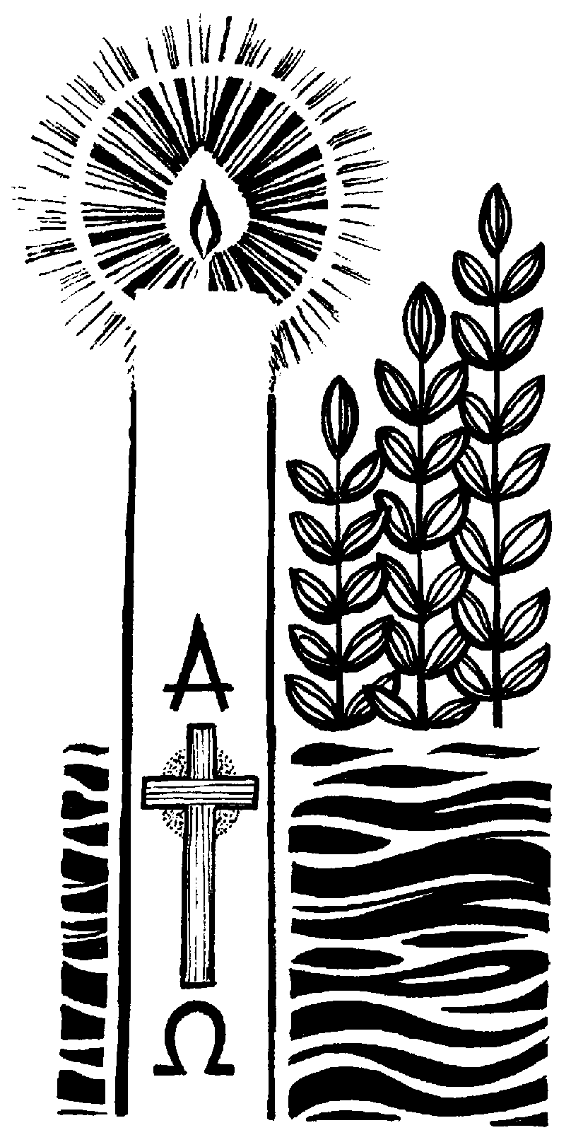

THURSDAY B

BENEDICTINE COMMUNITIES
TURVEY BEDFORDSHIRE
These pages are provided for the private use of those who join the communities in the chapel at Turvey Abbey for Vespers via the Turvey Abbey YouTube channel.

Psalms(1963 edition) © The Grail
Magnificat © The Grail
clip art © Turvey Abbey
layout © Turvey Abbey



www.turveyabbey.org.uk/

HYMN

Hundert Arien, Dresden 1694
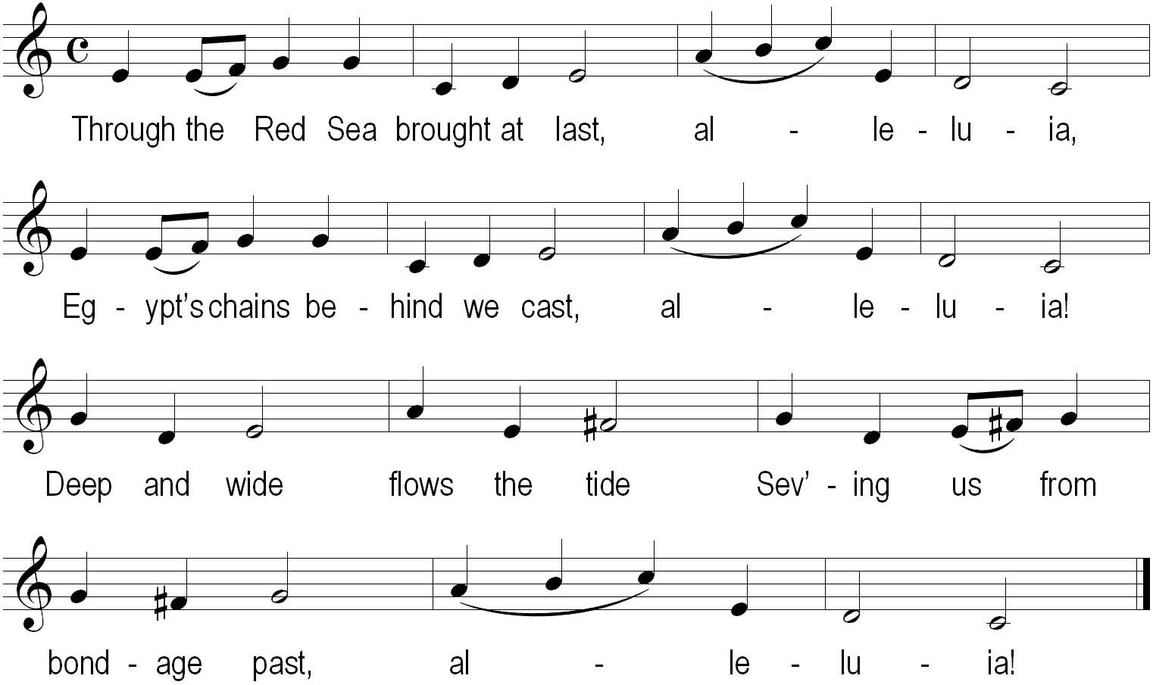
Like the cloud that overhead, alleluia,
Through the waters Israel led, alleluia,
By his tomb Christ makes room,
Souls restoring from the dead, alleluia!
In that cloud and in that sea, alleluia,
Buried and baptised were we, alleluia!
Earthly night brought us light,
Which is ours eternally, alleluia!
Ronald A. Knox 1888–1957

VESPERS IN EASTERTIDE THURSDAY B

O God, come to our aid,
O Lord, make haste to help us.
Glory be to the Father and to the Son and to the Holy Spirit,
as it was in the beginning, is now
and shall be for ever, amen. Alleluia!

HYMN

Antiphon 1: The Lord * fills the earth with his love, alleluia!


Psalm 32
Ring out your joy to the Lord, O you just;
All: for praise is fitting for loyal hearts.
Give thanks to the Lord upon the harp,
with a ten-stringed lute sing him songs.
O sing him a song that is new,
play loudly, with all your skill.
For the word of the Lord is faithful
and all his works to be trusted.
The Lord loves justice and right
and fills the earth with his love.
By his word the heavens were made,
by the breath of his mouth all the stars.
He collects the waves of the ocean;
he stores up the depths of the sea.
Let all the earth fear the Lord,
all who live in the world revere him.
He spoke; and it came to be.
He commanded; it sprang into being.
He frustrates the designs of the nations,
he defeats the plans of the peoples.
His own designs shall stand for ever,
the plans of his heart from age to age.
They are happy, whose God is the Lord,
the people he has chosen as his own.
From the heavens the Lord looks forth,
he sees all the children of men.
From the place where he dwells he gazes
on all the dwellers on the earth,
he who shapes the hearts of them all
and considers all their deeds.
A king is not saved by his army,
nor a warrior preserved by his strength.
A vain hope for safety is the horse;
despite its power it cannot save.
The Lord looks on those who revere him,
on those who hope in his love,
to rescue their souls from death,
to keep them alive in famine.
Our soul is waiting for the Lord.
The Lord is our help and our shield.
In him do our hearts find joy.
We trust in his holy name.
May your love be upon us, O Lord,
as we place all our hope in you.
Glory be to the Father and to the Son
and to the Holy Spirit,
as it was in the beginning, is now
and shall be for ever, amen.
Antiphon 1: The Lord * fills the earth with his love, alleluia!

Antiphon 2: The bread * that I shall give is my flesh for the life of the world, alleluia!


Psalm 40
Happy the man who considers the poor and the weak.
The Lord will save him in the day of evil,
will guard him, give him life, make him happy in the land
and will not give him up to the will of his foes.
The Lord will help him on his bed of pain,
he will bring him back from sickness to health.
As for me, I said: ‘Lord, have mercy on me,
heal my soul for I have sinned against you.’
My foes are speaking evil against me.
‘How long before he dies and his name be forgotten?’
They come to visit me and speak empty words,
their hearts full of malice, they spread it abroad.
My enemies whisper together against me.
They all weigh up the evil which is on me:
‘Some deadly thing has fastened upon him,
he will not rise again from where he lies.’
Thus even my friend, in whom I trusted,
who ate my bread, has turned against me.
But you, O Lord, have mercy on me.
Let me rise once more and I will repay them.
By this I shall know that you are my friend,
if my foes do not shout in triumph over me.
If you uphold me I shall be unharmed
and set in your presence for evermore.
Blessed be the Lord, the God of Israel
from age to age. Amen. Amen.
Glory be to the Father, the Son and Holy Spirit,
both now and for ever, amen.
Antiphon 2: The bread * that I shall give is my flesh for the life of the world, alleluia!

Antiphon 3
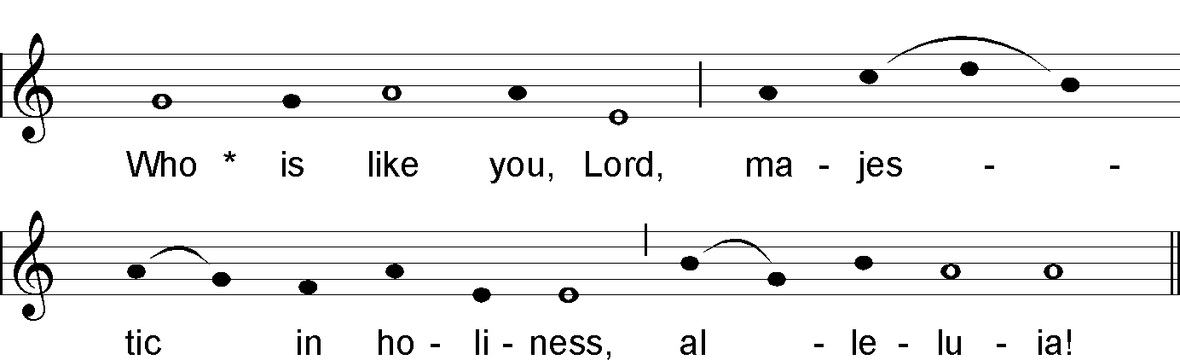

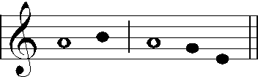

NT Canticle 20 (Rev 11:17–18;12:10b–12a)
We give thanks to you, Lord God Almighty,
who are and who were,
that you have taken your great power
and begun to reign.
The nations raged,
but your wrath came,
and the time for the dead to be judged,
for rewarding your servants, the prophets and saints,
and those who fear your name,
both small and great.
Now the salvation and the power and the kingdom of our God
and the authority of his Christ have come.
For the accuser of our brethren has been thrown down,
who accuses them day and night before our God.
And they have conquered him
by the blood of the Lamb
and by the word of their testimony,
for they loved not their lives even unto death.
Rejoice, then, O heaven,
and you that dwell therein.
Glory be to the Father, the Son and Holy Spirit,
both now and for ever, amen.
Antiphon 3: Who is like you, Lord, majestic in holiness, alleluia!

Antiphon 4: The Lord * is great in Zion; he is supreme above all peoples, alleluia!
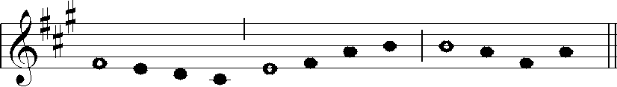

Psalm 98
The Lord is king; the peoples tremble.
He is throned on the cherubim; the earth quakes.
The Lord is great in Zion.
He is supreme over all the peoples.
Let them praise his name, so terrible and great.
he is holy, full of power.
You are a king who loves what is right;
you have established equity, justice and right;
you have established them in Jacob.
Exalt the Lord our God;
bow down before Zion, his footstool.
He the Lord is holy.
Among his priests were Aaron and Moses,
among those who invoked his name was Samuel.
They invoked the Lord and he answered.
To them he spoke in the pillar of cloud.
They did his will; they kept the law,
which he, the Lord, had given.
O Lord our God, you answered them.
For them you were a God who forgives;
yet you punished all their offences.
Exalt the Lord our God;
bow down before his holy mountain
for the Lord our God is holy.
Glory be to the Father and to the Son
and to the Holy Spirit,
both now and for ever, amen.
Antiphon 4: The Lord * is great in Zion; he is supreme above all peoples, alleluia!

SCRIPTURE READING

RESPONSORY

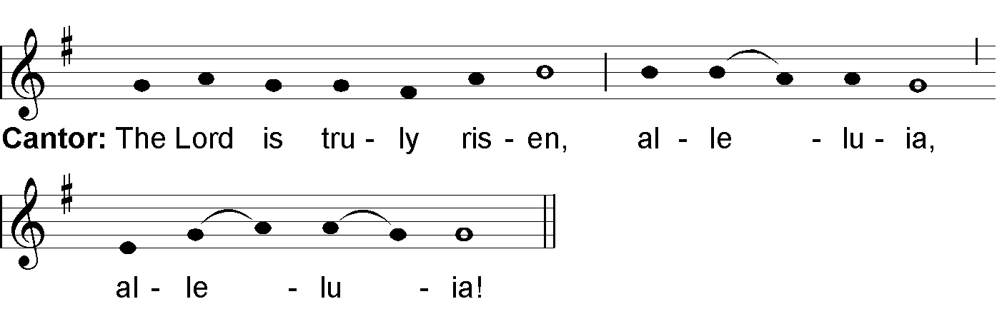

All Repeat

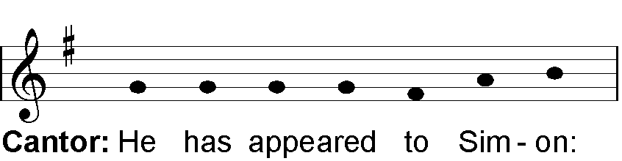

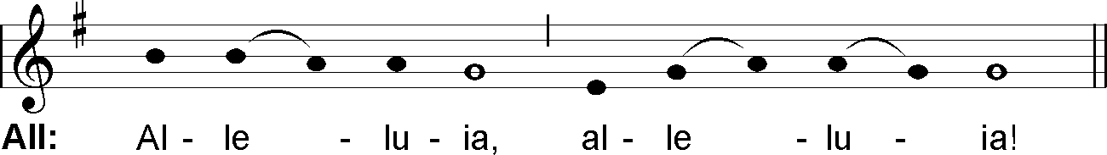

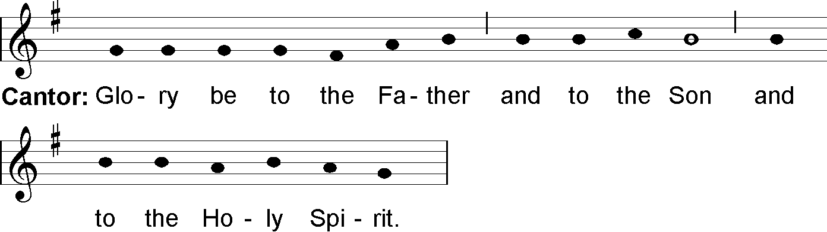

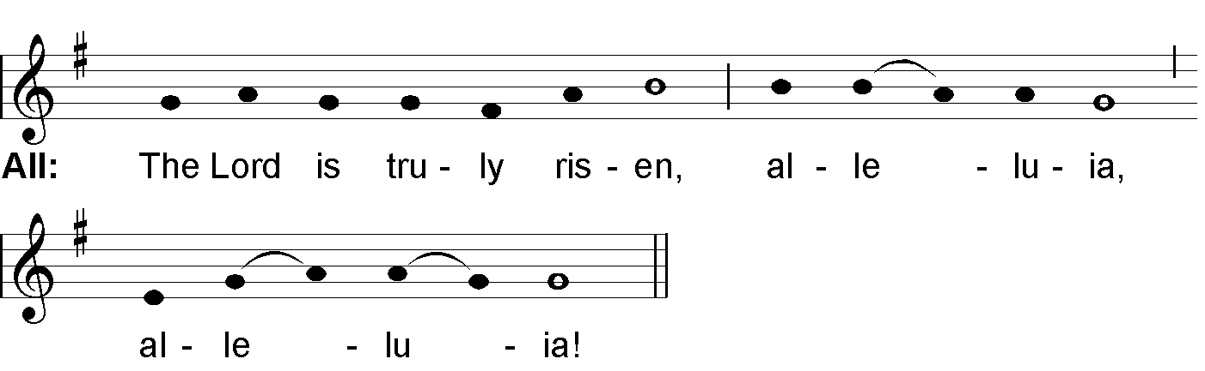

MAGNIFICAT ANTIPHON

Week 2
Anyone * who believes in the Son has eternal life, alleluia!

Week 4
I am * the shepherd of the flock; I have come so that they may have life, and have it to the full, alleluia!

MAGNIFICAT (Luke 1:46–55)
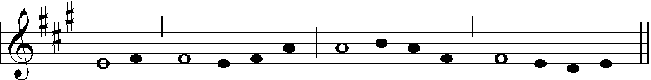

My soul glorifies the Lord,
my spirit rejoices in God, my Saviour.
He looks on his servant in her lowliness;
henceforth all ages will call me blessed.
The Almighty works marvels for me.
Holy his name!
His mercy is from age to age,
on those who fear him.
He puts forth his arm in strength
and scatters the proud-hearted.
He casts the mighty from their thrones
and raises the lowly.
He fills the starving with good things,
sends the rich away empty.
He protects Israel, his servant,
remembering his mercy,
the mercy promised to our fathers,
to Abraham and his sons for ever.
Glory be to the Father and to the Son
and to the Holy Spirit,
as it was in the beginning, is now
and shall be for ever, amen.
Repeat Antiphon

INTERCESSIONS

OUR FATHER (said by the Superior)

CONCLUDING PRAYER

LET US BLESS THE LORD, ALLELUIA!
THANKS BE TO GOD, ALLELUIA!

May the divine assistance remain always with us.
And with our absent brothers and sisters. Amen.

