EASTERTIDE VESPERS



FRIDAY B

BENEDICTINE COMMUNITIES
TURVEY BEDFORDSHIRE
These pages are provided for the private use of those who join the communities in the chapel at Turvey Abbey for Vespers via the Turvey Abbey YouTube channel.

Psalms(1963 edition) © The Grail
Magnificat © The Grail
clip art © Turvey Abbey
layout © Turvey Abbey



www.turveyabbey.org.uk/

HYMN

Hundert Arien, Dresden 1694
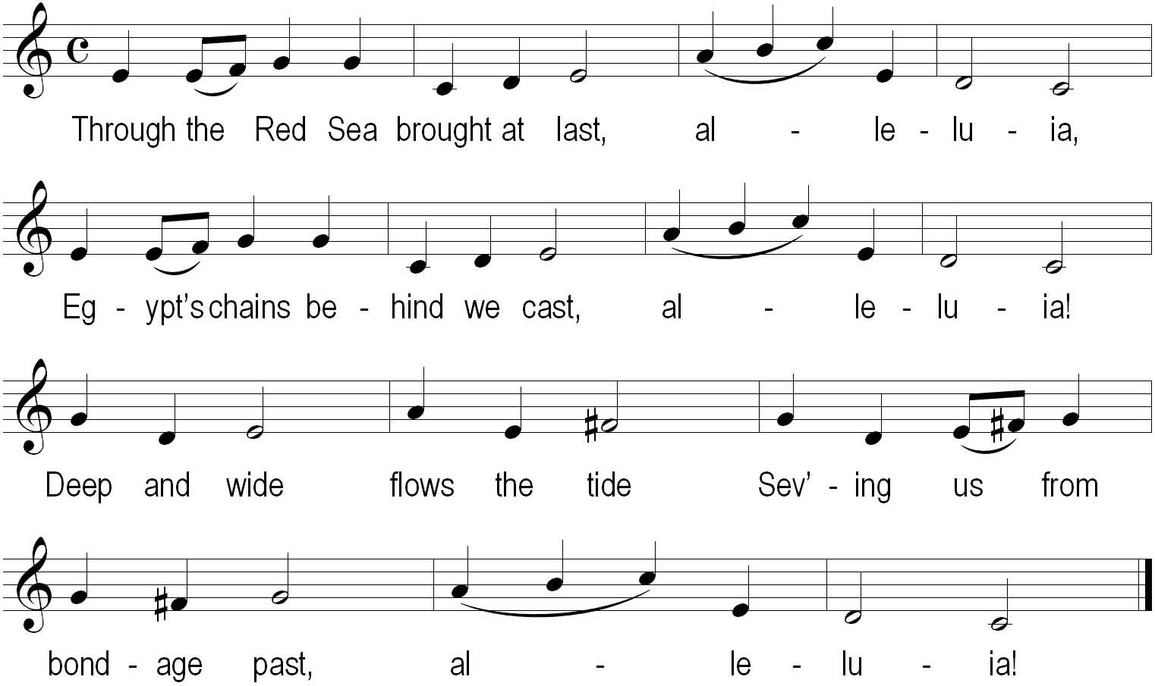
Like the cloud that overhead, alleluia,
Through the waters Israel led, alleluia,
By his tomb Christ makes room,
Souls restoring from the dead, alleluia!
In that cloud and in that sea, alleluia,
Buried and baptised were we, alleluia!
Earthly night brought us light,
Which is ours eternally, alleluia!
Ronald A. Knox 1888–1957

VESPERS IN EASTERTIDE FRIDAY B

O God, come to our aid,
O Lord, make haste to help us.
Glory be to the Father and to the Son and to the Holy Spirit,
as it was in the beginning, is now
and shall be for ever, amen. Alleluia!

HYMN

Antiphon 1: Was it not * ordained that the Christ should suffer these things, and so enter into his glory, alleluia!


Psalm 68
Save me, O God,
for the waters have risen to my neck.
I have sunk into the mud of the deep
and there is no foothold.
I have entered the waters of the deep
and the waves overwhelm me.
I am wearied with all my crying.
my throat is parched.
My eyes are wasted away
from looking for my God.
More numerous than the hairs on my head
are those who hate me without cause.
Those who attack me with lies
are too much for my strength.
How can I restore
what I have never stolen?
O God, you know my sinful folly;
my sins you can see.
Let those who hope in you not be put to shame
through me, Lord of hosts:
let not those who seek you be dismayed
through me, God of Israel.

It is for you that I suffer taunts,
that shame covers my face,
that I have become a stranger to my brothers,
an alien to my own mother’s sons.
I burn with zeal for your house
and taunts against you fall on me.
When I afflict my soul with fasting
they make it a taunt against me.
When I put on sackcloth in mourning
then they make me a byword,
the gossip of men at the gates,
the subject of drunkards’ songs.
This is my prayer to you,
my prayer for your favour.
In your great love, answer me, O God,
with your help that never fails:
rescue me from sinking in the mud;
save me from my foes.
Save me from the waters of the deep
lest the waves overwhelm me.
Do not let the deep engulf me
nor death close its mouth on me.

(This section is read)

Lord, answer, for your love is kind;
in your compassion, turn towards me.
Do not hide your face from your servant;
answer quickly for I am in distress.
Come close to my soul and redeem me;
ransom me pressed by my foes.
You know how they taunt and deride me;
my oppressors are all before you.
Taunts have broken my heart;
I have reached the end of my strength.
I looked in vain for compassion,
for consolers; not one could I find.

For food they gave me poison;
in my thirst they gave me vinegar to drink.
Let their table be a snare to them
and their festive banquets a trap.
Let their eyes grow dim and blind;
let their limbs tremble and shake.
Pour out your anger upon them,
let the heat of your fury overtake them.
Let their camp be left desolate;
let no one dwell in their tents:
for they persecute one whom you struck;
they increase the pain of him you wounded.
Charge them with guilt upon guilt;
let them never be found just in your sight.
Blot them out from the book of the living;
do not enrol them among the just.
As for me in my poverty and pain
let your help, O God, lift me up.

I will praise God’s name with a song;
I will glorify him with thanksgiving.
A gift pleasing God more than oxen,
more than beasts prepared for sacrifice.
The poor when they see it will be glad
and God-seeking hearts will revive;
for the Lord listens to the needy
and does not spurn his servants in their chains.
Let the heavens and the earth give him praise,
the sea and all its living creatures.
(
For God will bring help to Zion
and rebuild the cities of Judah
and men shall dwell there in possession.
The sons of his servants shall inherit it;
those who love his name shall dwell there.
Glory be to the Father, the Son and Holy Spirit,
both now and for ever, amen.
Antiphon 1: Was it not * ordained that the Christ should suffer these things, and so enter into his glory, alleluia!

Antiphon 2
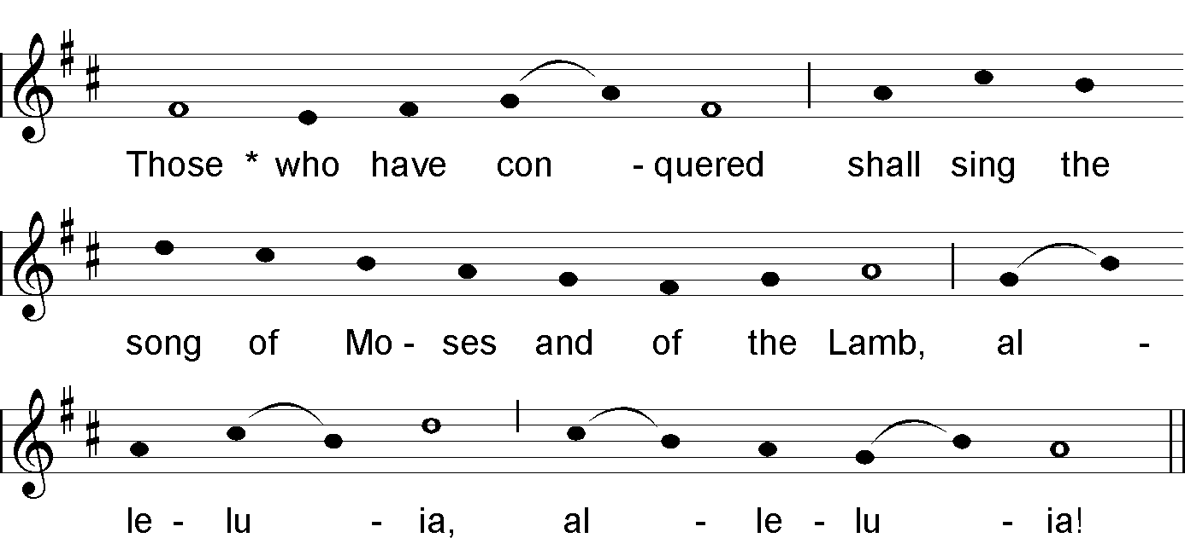



NT Canticle 21

(Revelation 15:3–4)
Great and wonderful are your deeds,
O Lord God, the Almighty!
Just and true are your ways,
O King of the ages!
Who shall not fear and glorify your name, O Lord,
for you alone are holy!
All nations shall come and worship you,
for your judgements have been revealed.
Glory be to the Father and to the Son
and to the Holy Spirit,
as it was in the beginning, is now
and shall be for ever, amen.
Repeat Antiphon

Antiphon 3: Alleluia! * Worthy are you, our Lord and God, to receive glory and honour and power, alleluia!
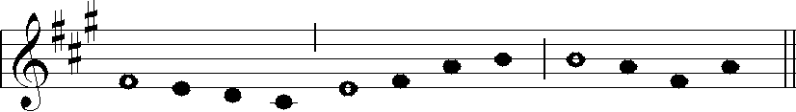

Psalm 92
The Lord is king, with majesty enrobed;
the Lord has robed himself with might,
he has girded himself with power.
The world you made firm, not to be moved;
your throne has stood firm from of old.
From all eternity, O Lord, you are.
The waters have lifted up, O Lord,
the waters have lifted up their voice,
the waters have lifted up their thunder.
Greater than the roar of mighty waters,
more glorious than the surgings of the sea,
the Lord is glorious on high.
Truly your decrees are to be trusted.
Holiness is fitting to your house,
O Lord, until the end of time.
Glory be to the Father and to the Son
and to the Holy Spirit,
both now and for ever, amen.
Antiphon 3: Alleluia! * Worthy are you, our Lord and God, to receive glory and honour and power, alleluia!

SCRIPTURE READING

RESPONSORY

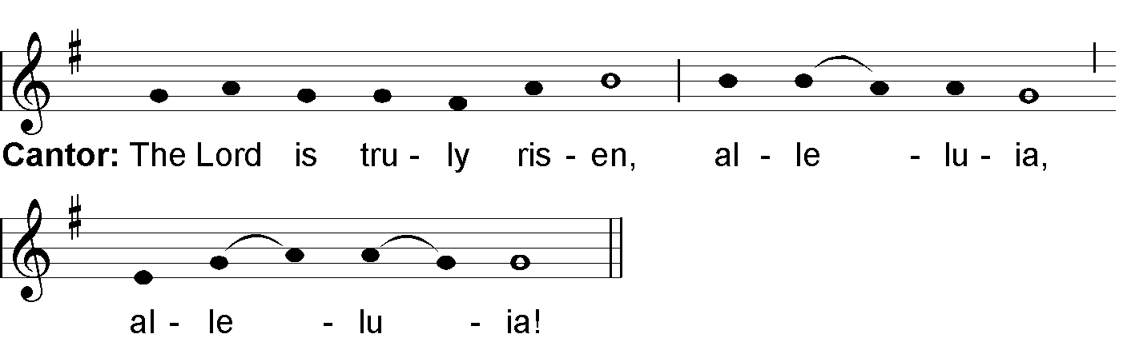

All Repeat

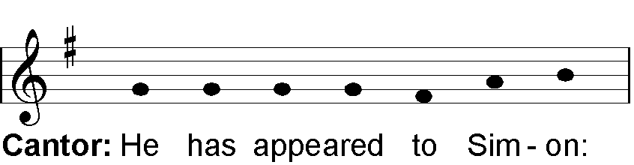

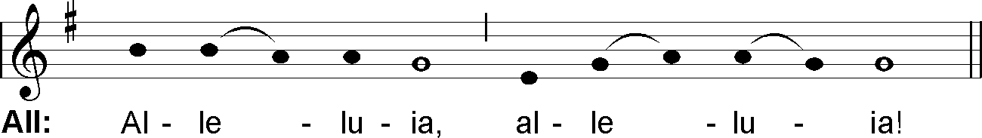

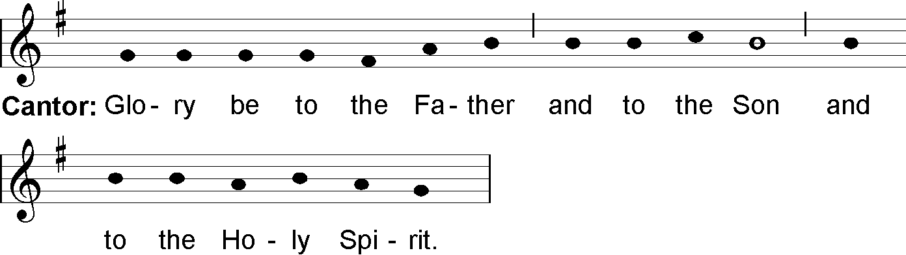

All: The Lord is truly risen, alleluia, alleluia!

RESPONSORY FROM ASCENSION UNTIL PENTECOST

Send forth your Spirit, O Lord, and renew the face of the earth!

MAGNIFICAT ANTIPHON

Week 2
By submitting * to death on the cross he destroyed the power of hell, alleluia!

Week 4
The good shepherd * lays down his life for his sheep, alleluia!

Week 6
Your heavenly Father * will give the Holy Spirit to those who ask him, alleluia!

MAGNIFICAT (Luke 1:46–55)
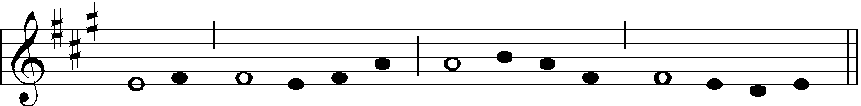

My soul glorifies the Lord,
my spirit rejoices in God, my Saviour.
He looks on his servant in her lowliness;
henceforth all ages will call me blessed.
The Almighty works marvels for me.
Holy his name!
His mercy is from age to age,
on those who fear him.
He puts forth his arm in strength
and scatters the proud-hearted.
He casts the mighty from their thrones
and raises the lowly.
He fills the starving with good things,
sends the rich away empty.
He protects Israel, his servant,
remembering his mercy,
the mercy promised to our fathers,
to Abraham and his sons for ever.
Glory be to the Father and to the Son
and to the Holy Spirit,
as it was in the beginning, is now
and shall be for ever, amen.
Repeat Antiphon

INTERCESSIONS

OUR FATHER (said by the Superior)

CONCLUDING PRAYER

LET US BLESS THE LORD, ALLELUIA!
THANKS BE TO GOD, ALLELUIA!

May the divine assistance remain always with us.
And with our absent brothers and sisters. Amen.



